Premise
To use streamlit as the dashboard.

Reasons
streamlit creates a web page, which is user configurable which means a far more flexible layout than PowerBI or Tableau which have fixed design protocols.
HTML and CSS support further expands possibilities even though streamlit is not 100% CSS/HTML compatible.
Python compatibility making duplicating Jupyter notebook sections into the streamlit application very easy. With the other dashboard applications ETL steps need to be created from scratch in their methodology!

Design Ethos
- Use HTML concepts such as DIV to create unique sections
- Use streamlit columns to segment contents of DIVs where necessary
- Use streamlit sidebar for main user options
- Use widgets for interactive charts and application navigation
- Use CSS to enhance the look and “feel” of the applications

Main Screen Design Concept

Streamlit title
Sales Analysis Project
Tab3
Tab2
Tab1

Sidebar Options

Streamlit tabs
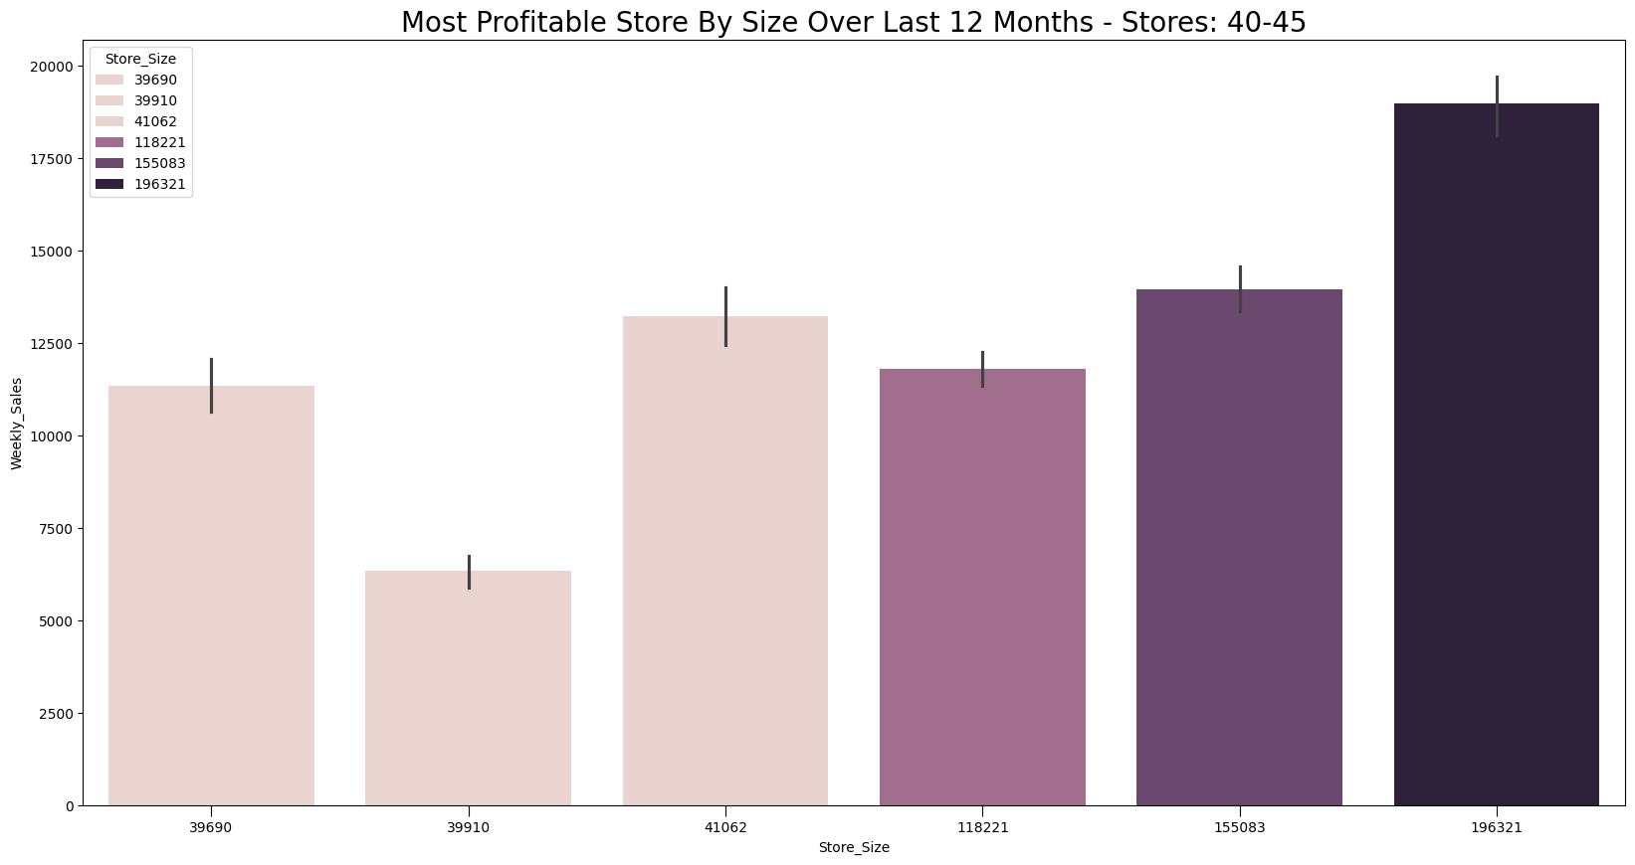
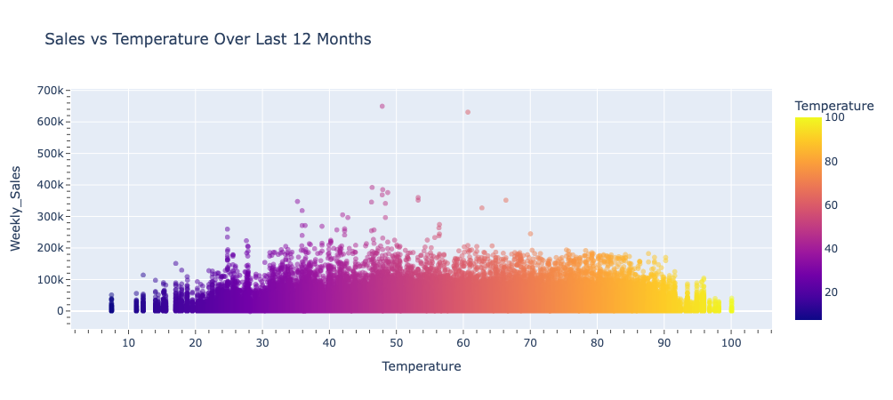
* Overview
* Analysis

Streamlit radio buttons



Streamlit sidebar



Streamlit columns

Streamlit containers

As we can see there is the sidebar on the left, then next to it one streamlit container. Inside that is a streamlit tab control.
Each time a tab is selected a sub container is created inside the main one, then inside that columns are created if needed.
Each streamlit component is given a KEY value if it is to be manipulated in CSS.
Colour scheme will determined via a “trail-and-error” methodology after testing, as at this time the colour theme for the project is undetermined. Also some consideration will be put into about the background colour of the plots, if it is feasible to change it then I will.
If possible will test idea with different screen resolutions.

